Street Trading Policy 2019 Consultation Responses

The following responses were received; where necessary, comments from the Business Regulation Team follows in black bold italic font:

1. To what extent do you agree or disagree with the additional criteria for considering
new street trading applications regarding offering for sale low/ sugar/sugar free
drinks?
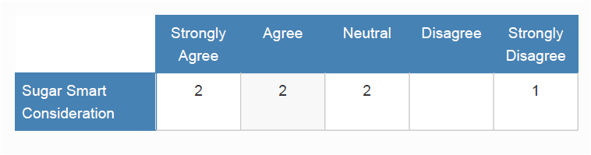
“Other healthy eating guidelines/criteria would also be useful.”

“Street traders do not on top of everything else need to become sugar police”

2. To what extent do you agree or disagree with the introduction of the new condition
under General Conditions for Street Trading Consents ' Street Trading Consent
holders must make full use of their Consent'?

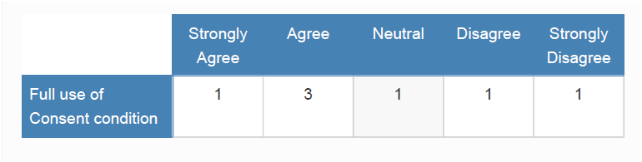

“It does not seem to fully consider special circumstances such as illness, bereavement etc.”

“Sometimes other factors intervene such as illness preventing attending all or part of a week”
Full consideration would be given by the Business Regulation Team in circumstances such as the ones given above.

3. To what extent do you agree or disagree with the additional application criteria
regarding the suitability of a street trading applicant and employees?

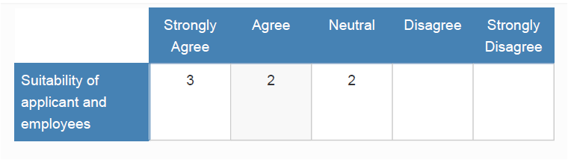
“As well as protecting the public - consideration should be made for those who already find it hard enough to re-enter society after having paid their dues for their offences.”

4. To what extent do you agree or disagree with the introduction of the new condition
under General Conditions for Street Trading Consents 'All packaging and utensils
for use by customers shall be made of recycled or part recycled materials'?

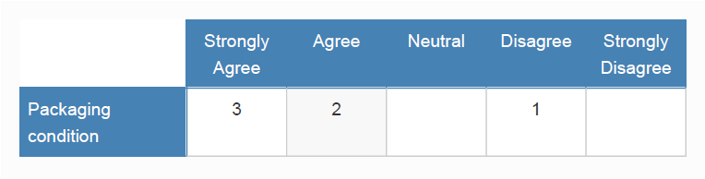

“Suggest all packaging should have message
BIN THIS BOX, CONTAINER, CUP, CARTON
stamped on them. These messages do work”

“Excellent idea, but as said message on all packaging to put in BIN”

5. Do you have any other comments in respect of the draft policy?

“I think that street trading is an important part of the city and well managed can continue to be beneficial. Policy should be helpful and not add unnecessary guidance.”

“I am not clear reading it whether the way fees are collected have changed. It seems to say they will be collected quarterly in advance. If this is the case it will be a very unwelcome change to an infrequent trader like myself.
Also this year, it has been noticeable that those who restrict their availability to summer months get many more weeks in the summer than those of us who trade through the year. This is unfair as our best business is in the summer (up to 3 fold) and I think a person who says they are only available for 3 months should only be allocated 0.25 x the allocation given per trader not an equal share allocated in their restricted time. Otherwise all of us will restrict our trading to summer only.
Another issue is lack of parking. There are only two traders, and it would be helpful if you could allocate two paid parking spaces for the traders. We often have to park at the park and ride leaving the stall and jewellery unattended in the street for 40 minutes.”

The above comments relate to weekly Street Trading Consent. For those traders the way the fee is collected (two weeks prior to trading) has not been changed during the policy review. Quarterly payments are for annual Street Trading Consent holders.

Allocation of trading weeks relating to weekly street trading is already carried out in the way suggested.

Due to vehicle restrictions in place on Cornmarket Street the Council is unable to provide parking spaces for the weekly street traders.

